

***CHAPTER 05 - Smart Water Management with “scada” System***



**5.1 Introduction:**

Dhaka Water Supply and Sewerage Authority (DWASA) is the Government authority for water supply and sewage disposal of the city Dhaka, DWASA operates a big water production and distribution network. The pumping stations equipped with deep tube wells, are the main network nodes of the system. DWASA management wants to implement a SCADA (Supervisory Control and Acquisition) system in the network, complete with remote monitoring and control. For that reason, DWASA management had formed a committee to produce a conceptual overview to WASA for a unified, fully integrated Central SCADA Platform with Interactive loT and HMI Dashboard. The report meant to provide a brief overview of the architecture and framework that has been envisioned by the SCADA Committee for deploying the ideal solution at Dhaka WASA. This automation guideline was meant to guide water production and distribution monitoring and control processes mainly.

Although I was not an official member of the SCADA committee, as divisional head of Planning and Design (Electrical & Mechanical) division I worked with the team, joined their meetings and gave inputs into the planning.

**5.2 What is SCADA:**

**SCADA stands for: Supervisory Control & Data Acquisition**

* It is a technology to collect data and monitor the performance of production and distribution processes.
* It is an application that can help to increase efficiency, lower costs and increase the profitability of operations by turning data into information.
* Reduce manpower needed for operation and monitoring activities thus reducing costs.

**Activities of a SCADA System:**

1. Data acquisition through sensors from various field devices.
2. Data transfer using communication network to various RTU, Local SCADA or Central SCADA.
3. Data processing and data or information presentation
4. User authentication and user access control into the SCADA monitoring and control system based upon various levels of user roles.
5. Instruments Control – Control various pumps motors, valves and chlorination systems remotely.

**SCADA system monitoring parameters for measurement and control:**

1. Pump on/off & pump running time
2. Power consumption for safety, billing and efficiency
3. Chlorine cylinder full or empty.
4. Pressure & flow measurement.
5. Failures & malfunctioning of electrical or mechanical devices.
6. Water level in well/ Dry-running protection system
7. Water sensor in DMA chamber etc.

**SCADA system outputs:** Alarm analysis. Trend analysis. Periodic reports.

**5.3 Existing Status of SCADA:**

In 2017, Dhaka WASA started the piloting project work for DTW (Deep Tube Well) SCADA, and has covered 163 out of 913 DTW under SCADA systems. Around 8 (eight) company was done this work. Above them 77 DTW has done by one vendor and he had sold the License software to Dhaka WASA and also found that the software is not perfect to fulfil WASA requirements. All SCADA are running under the vendor-controlled demo software. Vendors used several different field devices as well as different demo software which is running at vendor end. On the other hand, total 23 used such communication device which are infeasible to integrate into central SCADA.

Two type of standardized Demo software was used named Rockwell Talk View and SIEMENS WINCC software. On the other hand, one company had used own developed customized software which is cloud based hosting.

Saidabad Water Treatment Plant SCADA: In Dhaka WASA, Three WTP has used SCADA for Plant. All SCADA brand are Schneider.

**5.8 Equipment needed in a SCADA system:**

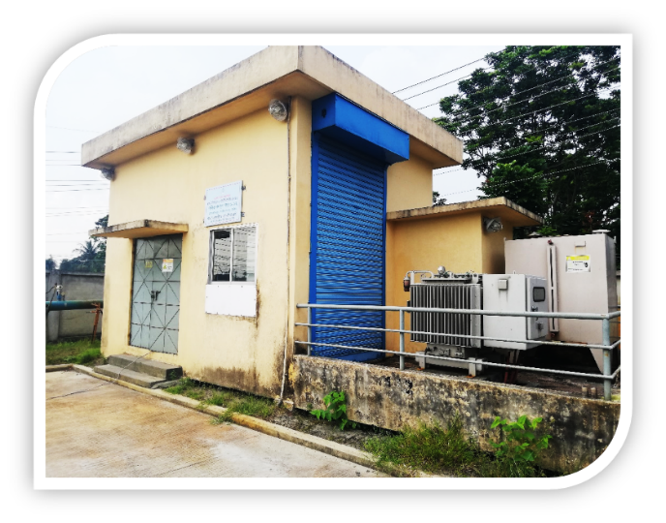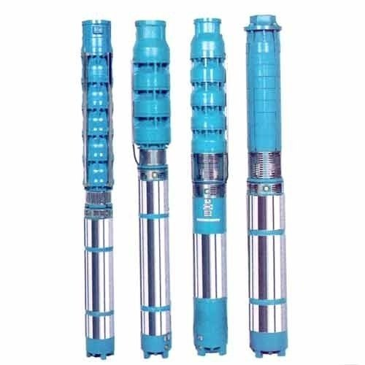

Deep Tube-well with substation- Submersible pump house. Pump is places 400 feet deep underground to bring up water. Deep tube well pump house and surrounding facilities costs from 300,000 to 500,000 taka. Each submersible pump cost from 10, 00,000 to 16, 50,000 taka based upon capacity.

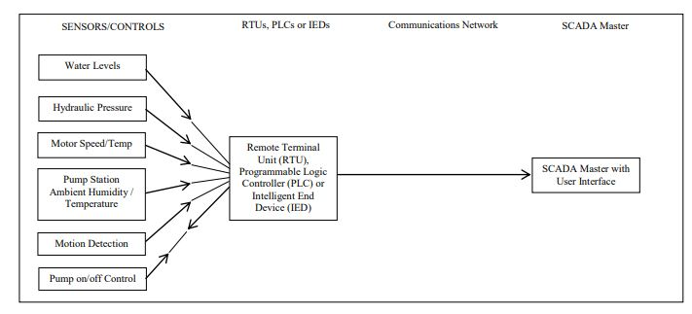

There are many components of SCADA systems in various places of DHAKA WASA. In this section we will look into common parts of SCADA.

SCADA systems historically have been broken down into two basic types:

**Proprietary SCADA System:**

• All or most components manufactured by one supplier

• Installation and service from same single source

• Lack of compatibility with other products

• Uses proprietary communications and programming

**Mix & Match SCADA System:**

• Usually supplied by System Integrator

• Usually uses open communication protocols

• Uses off-the-shelf products

• PLC’s program using standard procedures

• Utilizes open HMI Software

Original SCADA systems were proprietary. The Manufacturer built all the hardware, software, installed the equipment and did all the programming. As computer technology improved, SCADA systems evolved to take advantage of the advancement. Hardware components started coming off the shelf. SCADA software started to be developed to use open protocol communication standards. This led to the rise of System Integrators, companies that developed custom systems to meet the needs of the end users.

**SCADA SYSTEM COMPONENTS:**

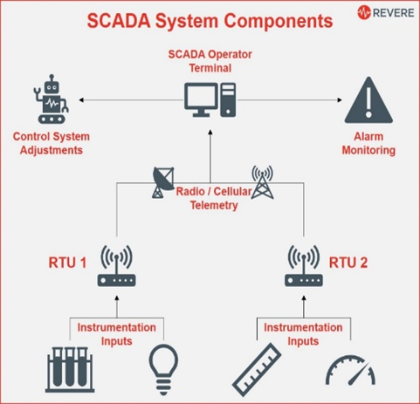

These are the four basic parts of a SCADA system.

• Field Instruments Inputs

• PLC/Remote Terminal Unit (RTU)

• Communications Link – open standard (like MODBUS) and proprietary Radio/Cellular, Ethernet, Telemetry systems.

• Central Computer Station including HMI Software – Proprietary for specific RTUs or open including interfacing many products, maintenance, alarm system, Top monitoring.

**Various equipment and tasks of SCADA system:**

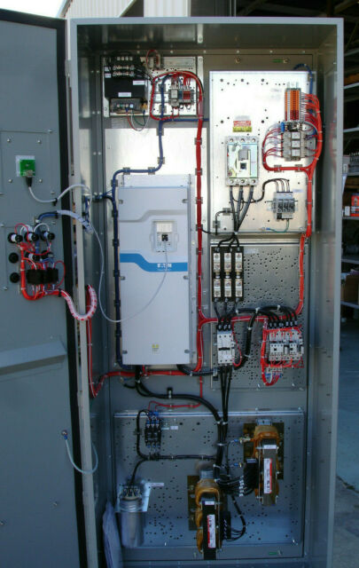

VFD - While not an essential instrument, a Variable Frequency Drive (VFD) is a field device that frequently interfaces with SCADA systems to control process outputs. VFD’s are used to power motors driving pumps and fans. VFD’s generate analog and discrete signals.

Typical signals from a VFD are: • Speed Indication (Analog) , • Speed Control (Analog) • Running (Discrete) • Fault (Discrete)

• Start Command (Discrete)

90 kw -110 kw VGD may cost 325,000 to 400,000 takas.

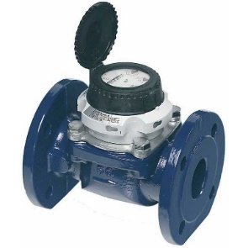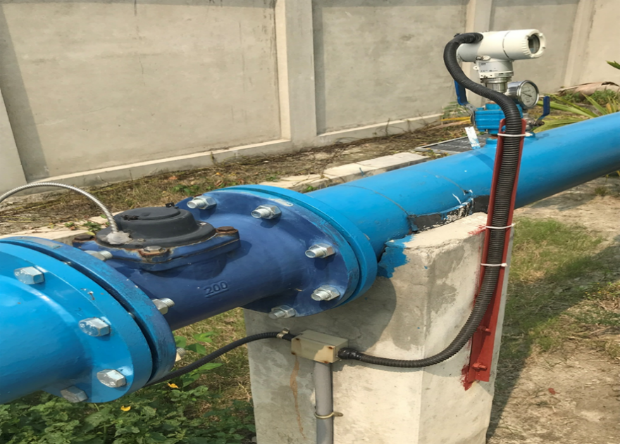

* Bulk water flow meter - A water flow meter is needed for measuring the amount of water passing through a pipe. The meter creates a pulse signal and transmits them to SCADA system or data loggers. Price of turbine type 200 mm Bulk water meter is around 100,000 taka.

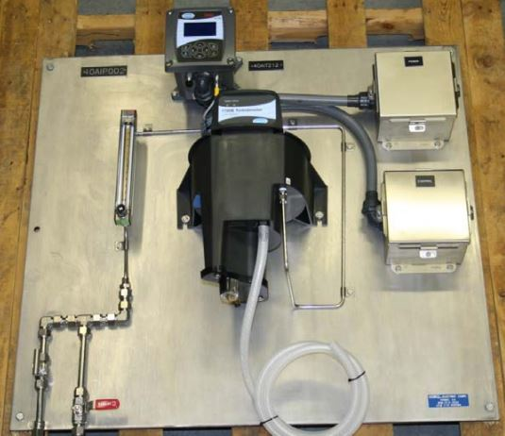

Turbidity meter - This is a turbidity meter used to measure solids in water. Price range 85,000-200,000 takas.

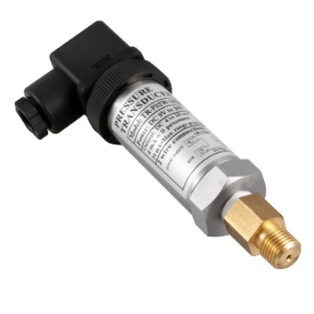

* Pressure Sensor - Pressure sensor is capable to detect the system pressure and convert it in an electrical signal. This allows the pressure to be monitored by SCADA or other relevant systems. Price is 15000 to 45000 takas.

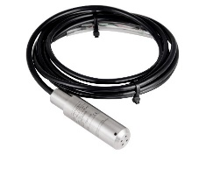

* Water Level Sensor - A water level sensor is a device that relays information back to a control panel to indicate whether the aquifer has a high or low water level. Borehole Water Level Sensor for Deep Well may cost around 50000-150000 takas.

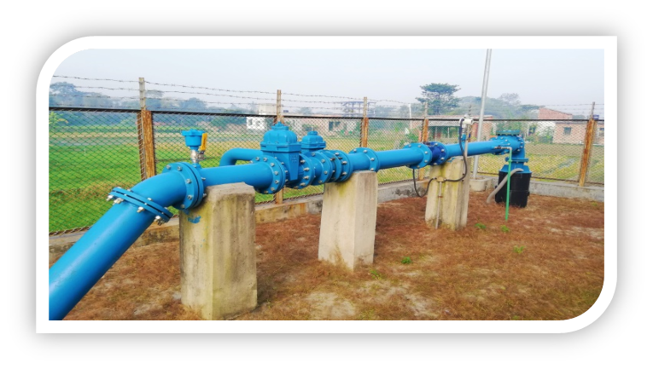

* Valves - A gate valve, also known as a sluice valve, is a valve that opens by lifting a barrier (gate) out of the path of the fluid. Gate valves require very little space along the pipe axis and hardly restrict the flow of fluid when the gate is fully opened. The gate faces can be parallel but are most commonly wedge-shaped (in order to be able to apply pressure on the sealing surface). Can be manually operated or automated. Valves of various types may cost 35000 to 150000 takas.

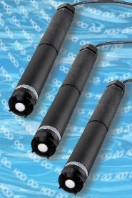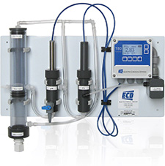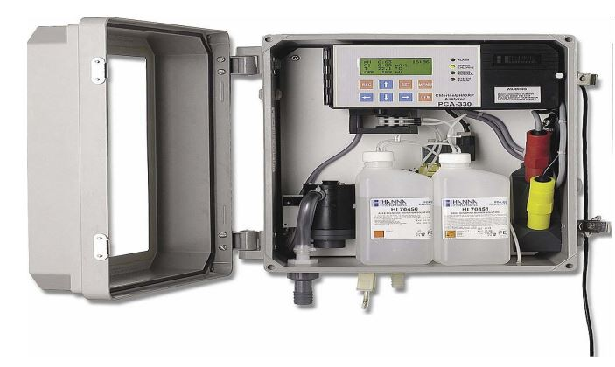

* Chlorination Sensor and Monitoring - Chlorination Sensor used in DWASA SCADA System shows if the chlorination unit is active or inactive. The Chlorination chamber has separate monitoring of the chlorine system. These can monitor chlorine in the water at the time of injection and residual chlorine in the water network pipelines. Various types of these units may cost 25000 to 50000 takas.

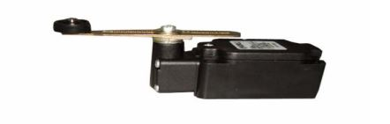

* Limit switches - Limit switches are used to automatically detect or sense the presence of an object or to monitor and indicate whether the movement limits of that object have been exceeded. The original use for limit switches, as implied by their name, was to define the limit or endpoint over which an object could travel before being stopped. It was at this point that the switch was engaged to control the limit of travel. Unit cost is 5000 to 15000 takas.

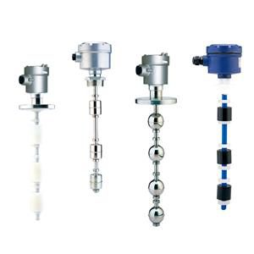

* Float switch - A float switch detects the level of a liquid in a tank or container. It floats on top of the liquid surface and acts as a mechanical switch as the liquid level goes up or down. They control devices like pumps (pump water in or out), valves (open or close inlet/outlets), or alarms to notify users. Unit cost is 5000 to 40000 takas.

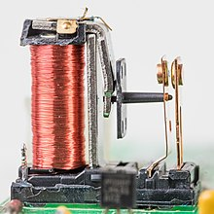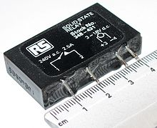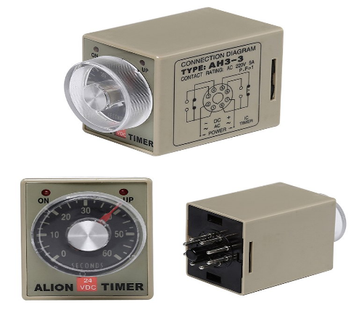

* Relays – Relay Contact switches are used where it is necessary to control a circuit by an independent low-power signal, or where several circuits must be controlled by one signal. A relay is an electrically operated switch. It consists of a set of input terminals for a single or multiple control signals, and a set of operating contact terminals. Unit cost 500 to 15000 takas.

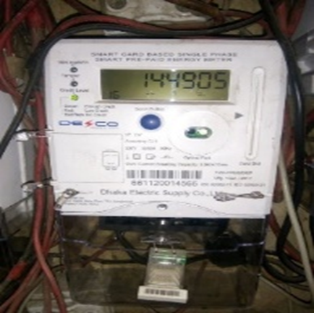

* Electric Meter - Electric Meter is sued to measure the amount of electricity use. This meter is also connected with SCADA system so that the energy consumption can be monitored. Cost of energy meter may vary from 15000 to 55000 takas.

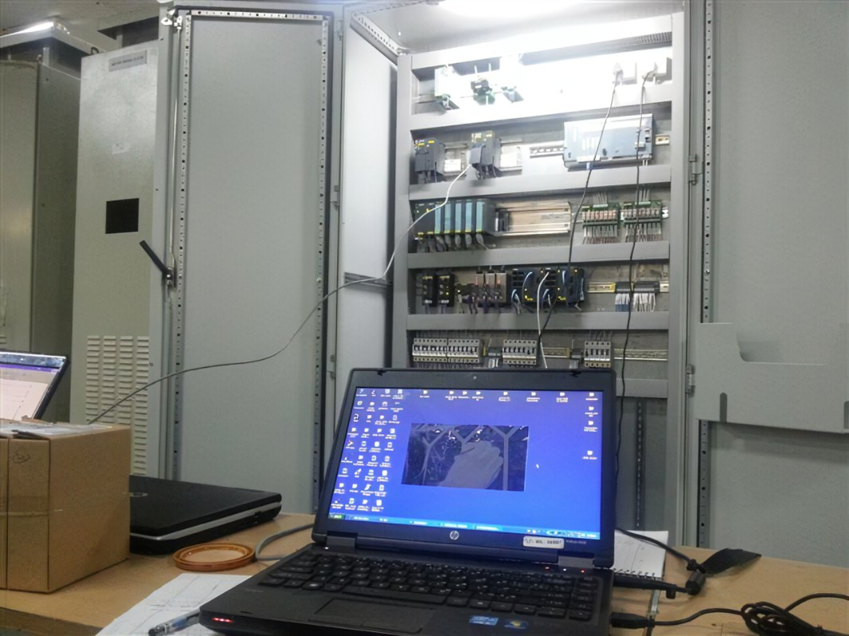

* RTU (Remote Terminal Unit) - Sensors and process controller devices are attached to remote terminal units (RTU). Multiple remote terminal units at different sites transmit the data collected to a single master station which displays the information in a browser. RTU package unit price range is 50000 – 500,000 takas.

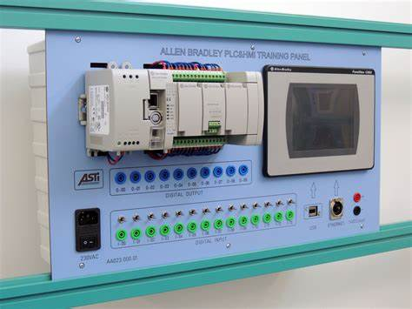

* HMI (Human-Machine Interface) - An HMI SCADA system, or SCADA Master, can provide several helpful extensions for network alarm management of monitoring equipment. If connected to an RTU, the gathered data can be filtered, analyzed, and monitored against functional standards. Out-of-range data can generate alerts to operators or maintenance personnel as required.

HMI software is used at the Central Control location. Software is installed on computers with faster processors and larger monitors so the screens display more information. They also make use of animation to emphasize critical data or focus operator attention to important areas of a process or annunciate an alarm. HMI modules may cost from 25000 to 50000 takas.

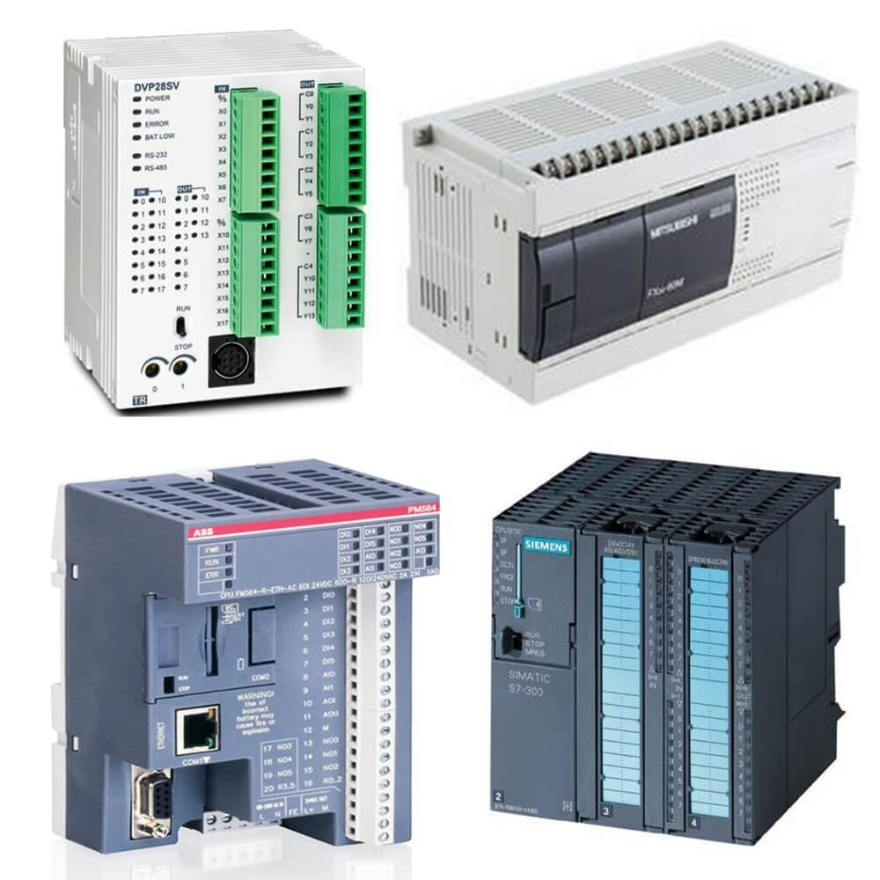

* PLC (Programmable Logic Controller) - Data from sensors on individual assets is transmitted to the PLC. The PLC translates that data into a format that can be used by the software. Users access the data through the HMI on the software. If the data crosses certain thresholds, a maintenance work order is created. The Programmable Logic Controller (PLC) was invented in 1968 to support the automobile industry by Bedford Associates’ engineer Dick Morley. The first PLC was called a Modular Digital Controller or MODICON. The work of the SCADA system that effectively grabs data from instruments, converts the information to a format a computer program can understand and handles high speed communication is the PLC. PLC and PLC modules unit cost is 10,000 to 50,000 and up-to 100,000 takas.

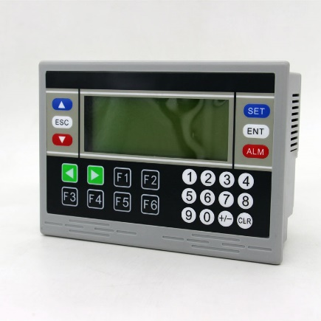

* OIT – Operator interface terminal OIT’s provide a local interface, typically in a remote location or into an isolated system like skid mounted equipment. Screens to display information have a simple layout since displays are not large; anywhere from 4 inches to 14 inches. Unit price 25000 to 55000 takas,

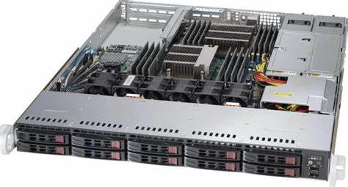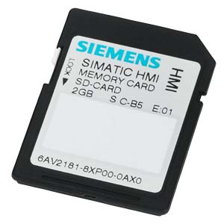

* Server and Memory Storage- Rack server and external memory chips and RAM. SD memory cards, RAM, Rack Servers costs 2000, 5000, 600000 takas.

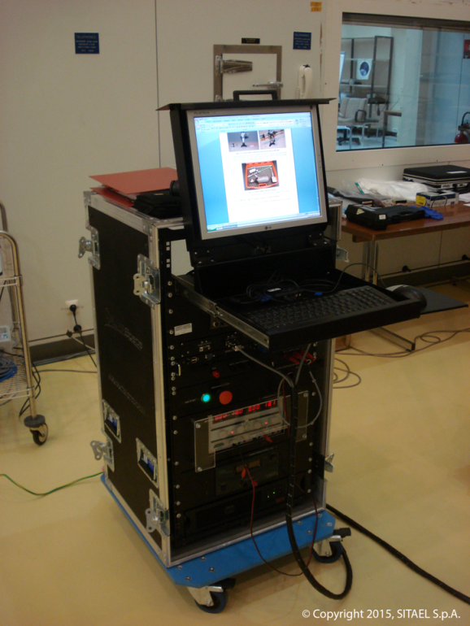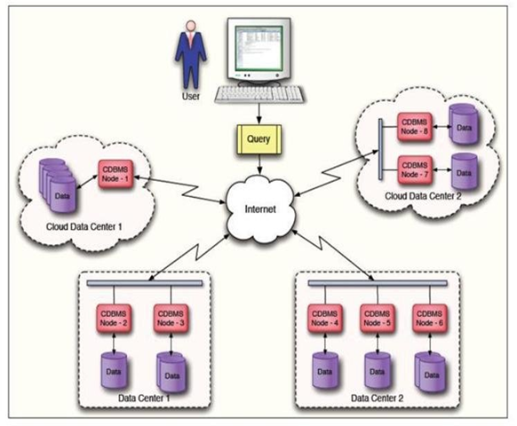

* Database server, cloud storage, backup server - To store the data and operated the equipment. These may cost 700 to 35,000 takas per month per Terabyte of data - in cloud or external Dedicated backup server respectively.

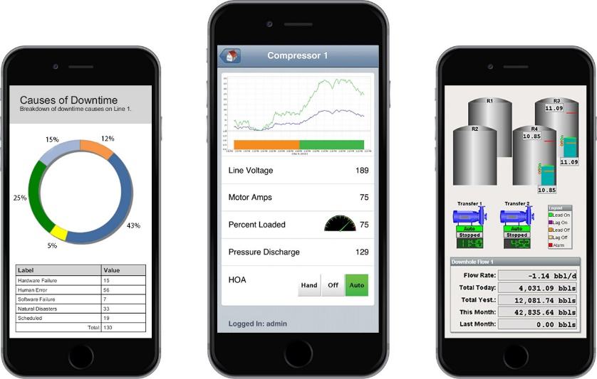

* Physical and mobile monitoring facility - Reading and analyzing on Desktop Computer, Laptop Computer, mobile, tablet, staff panel - To see the SCADA data and use it accordingly. Mobiles or tabs costs 15000 to 35000 takas.

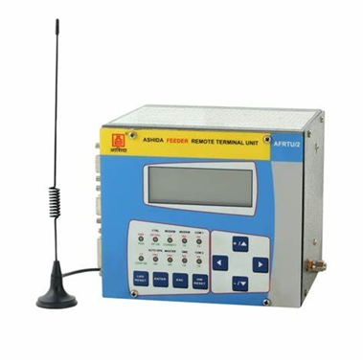 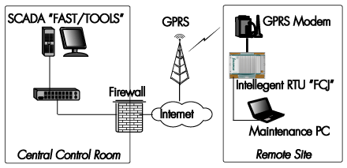

* Internet/radio frequency/GPRS - Wireless SCADA systems are the ones in which the communication between the Remote Terminal Unit (RTUs) and Human Machine Interface (HMI) is wireless in nature. General Packet Radio Service (GPRS) is the commonly used wireless technique used in wireless SCADA systems. Prices of unit range is 10,000 to 50,000 to 100,000 takas based upon model, power and capacity.

Radios are the most common communication method in large SCADA systems used in plants. Licensed radios were originally used. Then in 1987 the FCC marked a radio frequency band segment for Industrial Scientific Medical (ISM) use.

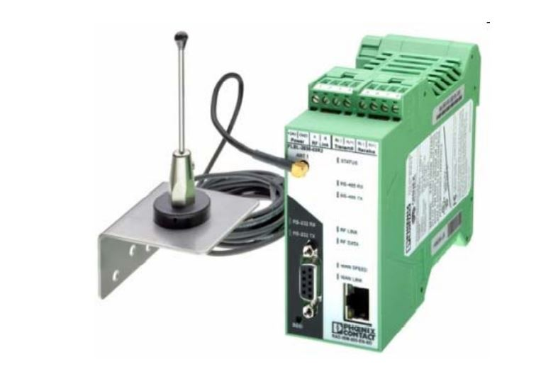

As electronics improved, radios became smaller while still keeping the same performance capabilities. This style of radio is designed to be mounted on DIN rail.

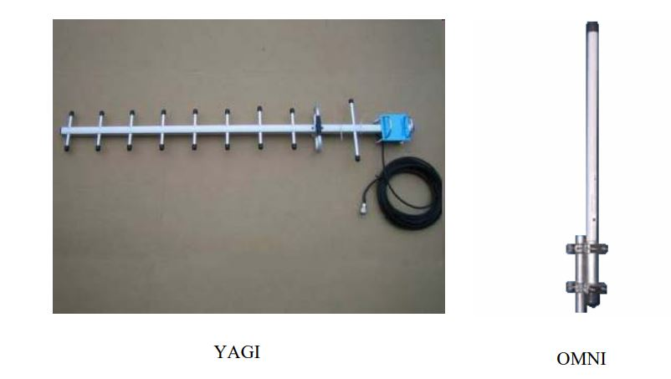

The two basic workhorse antennas of SCADA systems are YAGI and Omni. The yagi is for directional transmission and the omni provides 360 degrees of transmission. An omni antenna will be used at a SCADA Central site to broadcast to RTU’s at many different locations. The yagi antenna transmits radio signals in the direction the antenna is pointing. As higher radio frequencies (2.4 GHz and 5.8 GHz) have come into use for transmitting more data (e.g. video signals), panel and parabolic antennas are now common in SCADA Systems.

In addition to the traditional radio and serial cable communications, SCADA systems also use:

* Cellular. • Telephone Lines. • Wireless Internet / Wi-Fi or Microwave. • DSL Broadband / Ethernet • Fiber Optic. • Satellite.

**System Monitoring and Controlling Console:**

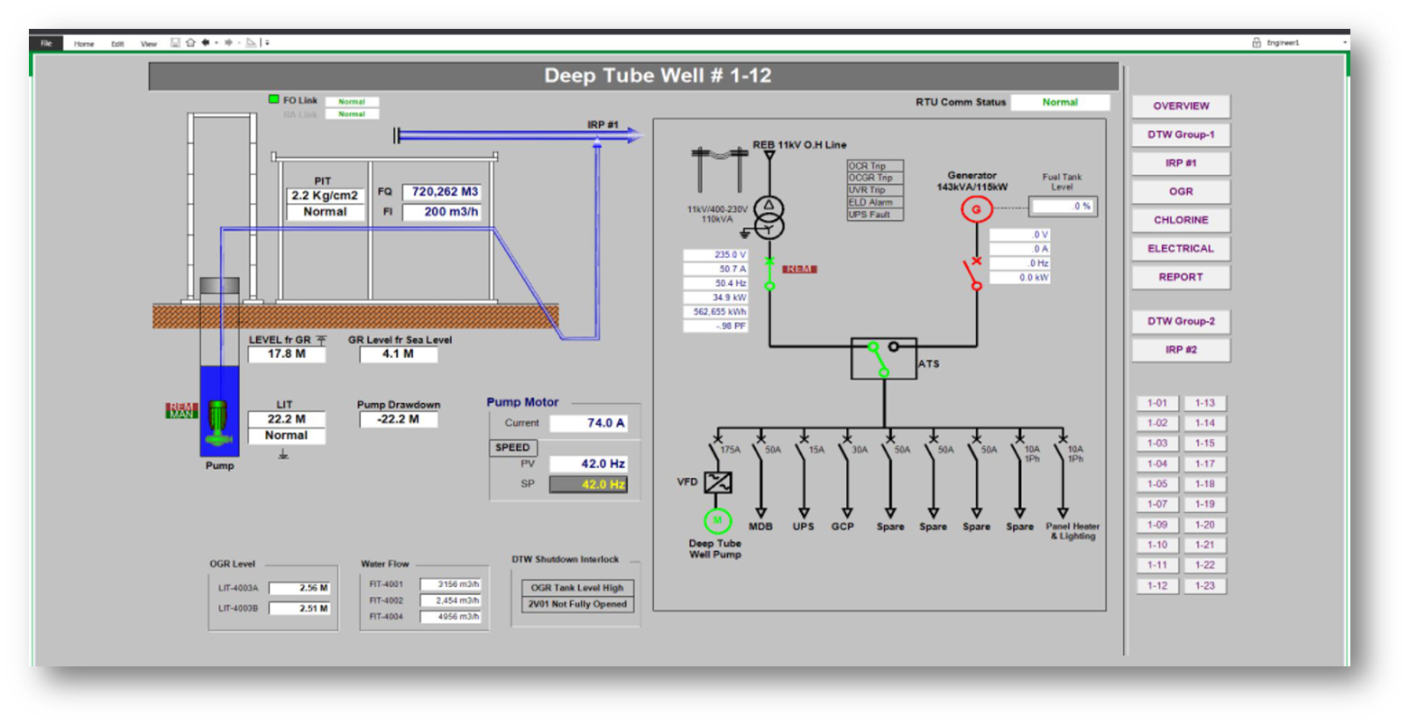

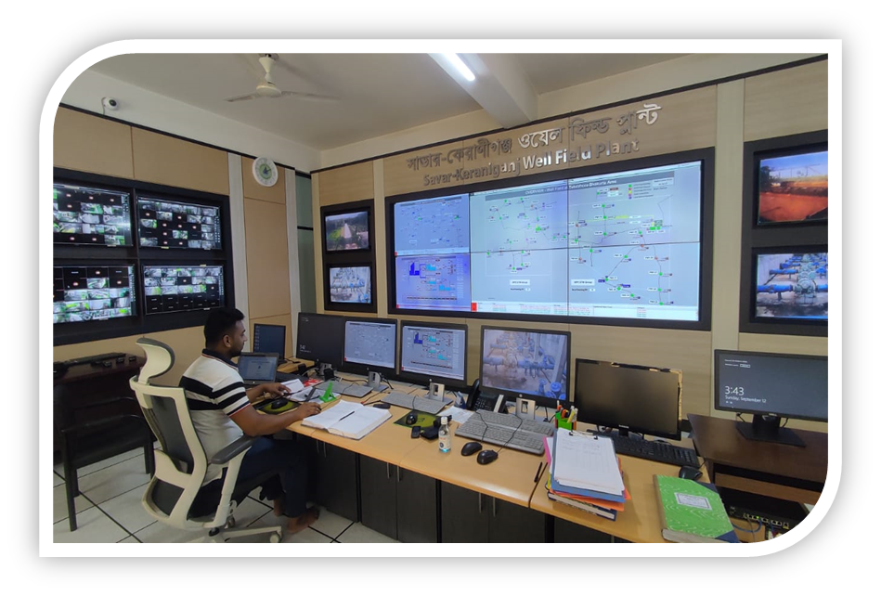

Control room equipment and furniture (system console) including but not limited to control console for dual redundant workstations, desk for engineering workstations. Servers, manager workstations and printer compartment along with chairs. The system console design shall be submitted to the Employer for prior approval, before starting any work. It may cost up-to 1,00,00,000 takas to establish a basic SCADA monitoring room for a water treatment plant.

**5.12 Training and Support services:**

* Maintenance and Support with the vendor will be Design Building Operation.
* The Contractor shall include maintenance support for all software components of the HMI and system software.
* The Contractor shall include maintenance support for all hardware.
* Training should include configuration interface, troubleshooting the SCADA system, display building, security and ongoing operation of provided hardware & computer software components.
* The Contractor will provide SCADA software service support, updates, and upgrades for a period of at least 5 years following completion of the Design and Build Phases of the DBO (Design, Build and Operation) Contract.
* Training, Warranty and after sales services may cost up-to 20% of total contract value.

**5.13 Importance of proper installation and maintenance:**

* Increase Life expectancy of equipment – pump, motor, meters or generators etc.
* Maintenance Cost reduction of all equipment.
* Safety of manpower and materials during operation.
* SCADA and Maintenance - SCADA is a useful tool for monitoring and operation of the equipment. SCADA is providing detailed information about the running machine. This can be used to customize a maintenance plan.

**5.14 Maintenance of SCADA and water production related equipment:**

Maintenance of water production equipment - Almost Every Electro-Mechanical equipment used by DWASA can be connected to SCADA system. Mechanical & Electrical instruments like Switches, Relays, Transformers, Generators, Vehicles, Pumps and Motors, Electrical panels, rotary type or turbine type mechanical or electromagnetic or ultrasonic water meters are used to produce and distribute water and measure the amount of water flow, Variable Frequency Drive/ VFD for controlling motor speed by changing frequency of current, Solar panels, Aerators, Blowers, Chlorine is injection machines to mix chlorine into water at a certain dose to kill germs, Chemical or Gas testing machines/ analyzers etc.

Those equipment are maintained by repairing or changing various parts, mainly after they fail. Many times, these are maintained by replacing the old equipment/machine with new ones. DWASA have equipment or workshop facilities to test and repair them with help from vendors. DHAKA WASA and Bangladeshi vendors have more than 50/70 years of experience in operating and maintaining those machines. For example, repairing or manufacturing various parts of pumps, motors, transformers, generators, vehicles, compressors/blowers etc. But those are not modern SCADA electronics equipment.

Maintenance of SCADA system equipment - SCADA system is relatively new in DWASA. As part of SCADA – Supervisory Control and Data Acquisition, various sensors, gauge or meters connected to production equipment - sensing or measuring various parameters of production equipment -  like pressure, temperature, flow, vibration, current, power, volt, current phases, frequency, operation state/condition etc. - sends those data through transmitters & wires to field RTU/PLC/computers to be processed and stored and send to command, monitoring and controlling places at various DWASA offices and at head office or central integrated command and control center .

Those latest technology electrical sensors, wires, communication devices, servers, Human Machine Interface / HMI, Online Chlorine Analyzer, harmful gas Analyzer, Chemical Chlorine Analyzer in water - all providing real-time data are sophisticated and smart Analogue or Digital electrical-electronics equipment. DWASA or Vendor technicians are not able to repair these devices. Those are maintained by replacing the whole device or sometimes replacing parts. DWASA don’t have equipment or labs/facilities, workshop to test or repair them.